Persistent Storage in Kubernetes Using AWS EBS CSI Driver

Submitted by: Sindhu Sahithi(23311A05T0),Asmitha Priyani(23311A05T2)
Course: DevOps / Cloud Computing
Institution: Sreenidhi Institute of Science And Technology
Date: 05/04/2026

1.Abstract
This project demonstrates the implementation of persistent storage in Kubernetes using the AWS EBS CSI Driver on Amazon EKS. In Kubernetes, pods are ephemeral, meaning data is lost when a pod is deleted or restarted. To overcome this limitation, persistent storage is required.
In this project, a MySQL application is deployed using a Persistent Volume Claim (PVC) backed by AWS Elastic Block Store (EBS). The EBS CSI driver dynamically provisions storage, ensuring that data persists even after pod deletion and recreation. The results confirm that the application retains its data, making the solution suitable for stateful applications such as databases.
This project provides hands-on experience in integrating Kubernetes with cloud storage services, demonstrating real-world DevOps practices.

2. Introduction
Kubernetes is widely used for deploying and managing containerized applications. However, one of the key challenges in Kubernetes is handling persistent data. By default, Kubernetes pods are ephemeral, meaning that any data stored inside the pod is lost when the pod is deleted or restarted.
This limitation creates a major issue for stateful applications such as databases, which require reliable and persistent storage. To address this, Kubernetes provides Persistent Volumes (PV) and Persistent Volume Claims (PVC), which allow applications to store data independently of the pod lifecycle.
In cloud environments like AWS, persistent storage can be dynamically provisioned using the Container Storage Interface (CSI). In this project, AWS Elastic Block Store (EBS) is integrated with Kubernetes through the EBS CSI Driver to provide scalable and durable storage.

3. Objectives
- To deploy a Kubernetes cluster using Amazon EKS
- To configure AWS CLI, kubectl, and eksctl tools
- To install and configure AWS EBS CSI Driver
- To create a StorageClass for dynamic storage provisioning
- To create Persistent Volume (PV) and Persistent Volume Claim (PVC)
- To deploy a MySQL application using persistent storage
- To verify data persistence after pod deletion

4. Tools And Technologies
- Amazon Web Services (AWS)
  - Amazon EKS
  - Amazon EC2
  - Amazon EBS
  - IAM
- Kubernetes
- AWS EBS CSI Driver
- kubectl
- eksctl
- MySQL
- YAML Configuration Files

5. Architecture

Architecture Flow:
User → Kubernetes Pod (MySQL) → Persistent Volume Claim (PVC) → Persistent Volume (PV) → AWS EBS Volume

The application pod uses a PVC to request storage. The PVC is bound to a PV, which is dynamically provisioned using AWS EBS. The EBS volume stores the data independently of the pod lifecycle.
The architecture consists of a Kubernetes cluster running on Amazon EKS. The MySQL application is deployed inside a pod, which uses a Persistent Volume Claim (PVC) to request storage. The PVC is dynamically bound to a Persistent Volume (PV) created using the AWS EBS CSI Driver. The PV is backed by an AWS EBS volume, which stores data independently of the pod lifecycle, ensuring persistence even after pod deletion.

6. Implementation
Step 1: Installed AWS CLI, kubectl, and eksctl
The required tools such as AWS CLI, kubectl, and eksctl were installed to interact with AWS and Kubernetes.
Step 2: Configured AWS CLI using access keys
AWS CLI was configured using IAM user access keys to enable authentication with AWS services.
Step 3: Created an EKS cluster using eksctl
Fig1: EKS Cluster Nodes:
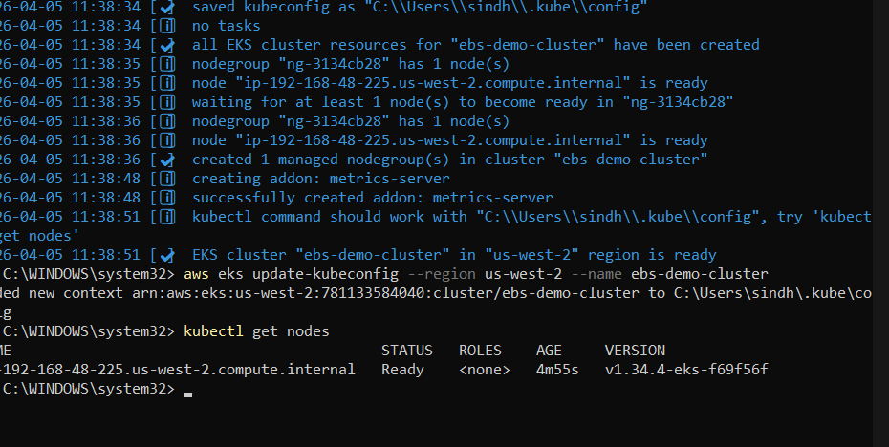
Fig1: EKS Cluster Nodes
An Amazon EKS cluster was created using eksctl, and the nodes were verified to be in a Ready state.
Step 4: Connected kubectl to the EKS cluster

Fig1: EKS Cluster Nodes

The kubectl tool was configured to communicate with the EKS cluster using kubeconfig.

Step 5: Installed AWS EBS CSI Driver
The AWS EBS CSI Driver was installed to enable dynamic provisioning of storage volumes.
Step 6: Created a StorageClass for dynamic provisioning
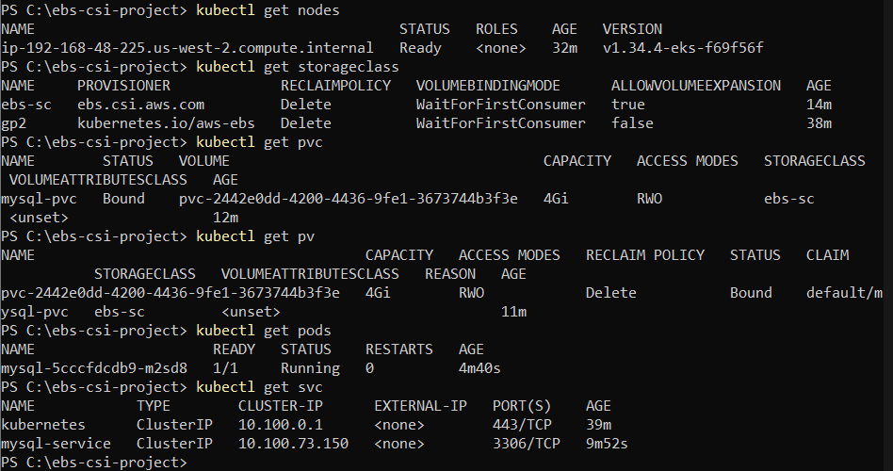
Figure 2: Kubernetes Storage Resources

A StorageClass was created to define how AWS EBS volumes are dynamically provisioned.

Step 7: Created a Persistent Volume Claim (PVC)
A Persistent Volume Claim (PVC) was created to request storage from the cluster. The PVC was automatically bound to a Persistent Volume (PV) provisioned using the EBS CSI driver.

Figure 2: Kubernetes Storage Resources
Step 8: Deployed MySQL application using PVC
A MySQL application was deployed using the PVC, ensuring that data is stored in persistent storage.
Step 9: Inserted sample data into MySQL database

Figure 3: Data Inserted into MySQL
Sample data was inserted into the MySQL database and verified using SQL queries.
Step 10: Deleted the pod to simulate failure
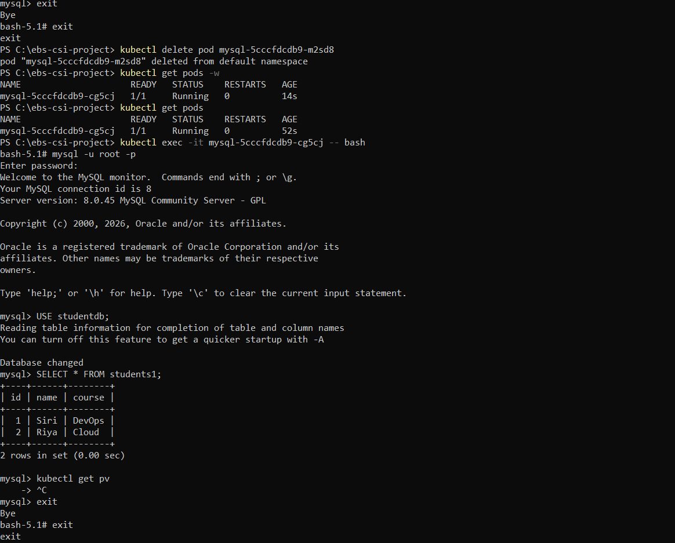
Figure 4: Pod Deletion and Recreation
The MySQL pod was deleted to simulate a failure scenario. Kubernetes automatically recreated the pod.
Step 11: Verified that data persisted after pod recreation
After the pod was recreated, the data remained intact, proving that persistent storage was successfully implemented.
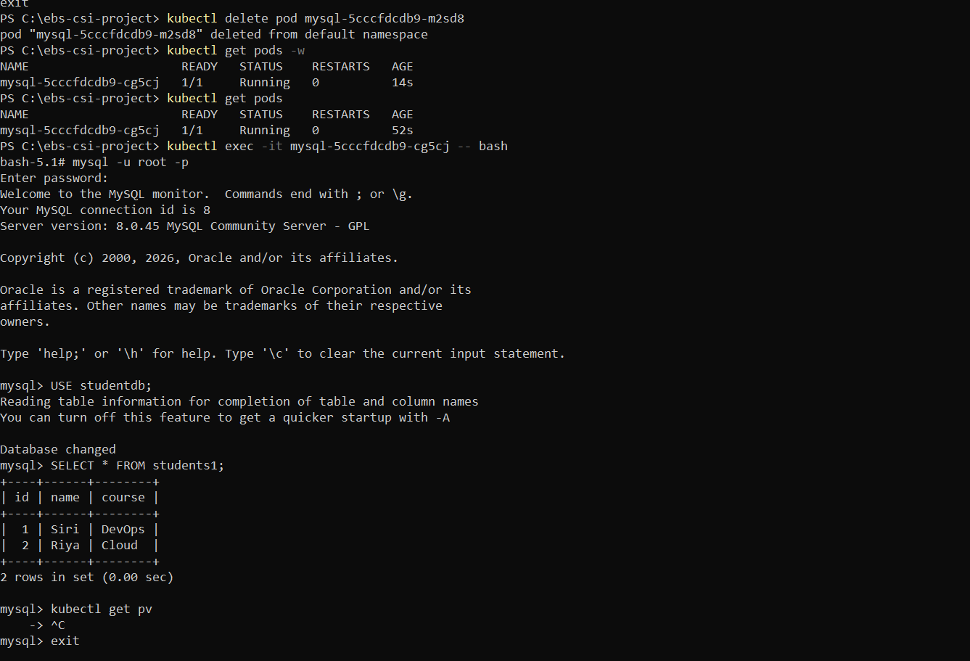
Figure 5: Data Persistence Verification
This confirms that Kubernetes persistent storage successfully retains data even after pod deletion.
AWS EBS Volume Corresponding to PV:
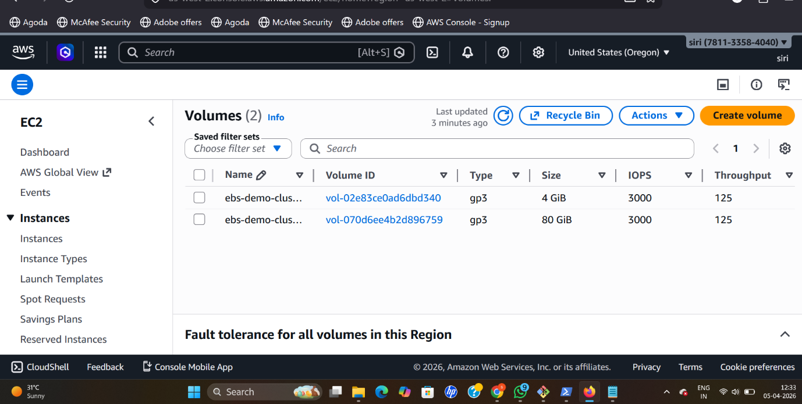
Figure 6: AWS EBS Volume

The AWS console shows the EBS volume associated with the Kubernetes Persistent Volume, confirming the integration.

7. Results And Output:
The MySQL database successfully retained its data even after the pod was deleted and recreated. This demonstrates the effectiveness of persistent storage in Kubernetes.
The Persistent Volume was dynamically provisioned using AWS EBS and remained attached to the application despite pod lifecycle changes. The data inserted before deletion was still available after the pod restarted.
Additionally, the AWS console displayed the EBS volume associated with the Kubernetes Persistent Volume, confirming the integration between Kubernetes and AWS.

8. Conclusion
This project successfully demonstrates the implementation of persistent storage in Kubernetes using AWS EBS CSI Driver. It highlights how Kubernetes overcomes the limitation of ephemeral storage by using Persistent Volumes and Persistent Volume Claims.
The integration with AWS ensures scalable, durable, and reliable storage, making it suitable for real-world applications such as databases and enterprise systems. This project provides valuable hands-on experience in DevOps and cloud-native technologies.

9. Future Scope
- Implement StatefulSets for advanced stateful applications
- Use shared storage solutions for multi-node applications
- Integrate monitoring and logging tools
- Extend the solution to other cloud platforms
- Automate deployments using CI/CD pipelines

10. Key learning Outcomes
- Understood Kubernetes persistent storage concepts
- Learned integration of AWS EBS with Kubernetes
- Gained experience with EKS cluster setup
- Implemented real-world stateful application
- Learned dynamic volume provisioning using CSI driver

